Jeff Sherard
CSC160C11
7/27/2013

Documentation for Ch09_Ex02 Program

Problem Analysis

Write a program that reads students’ names followed by their test scores. The program should output each student’s name followed by the test scores and the relevant grade. It should also find and print the highest test score and the name of the students having the highest test score.

Student data should be stored in a struct variable of type studentType , which has four components: studentFName and studentLName of type string , testScore of type int (testScore is between 0 and 100 ), and grade of type char. Suppose that the class has 20 students. Use an array of 20 components of type studentType .

Your program must contain at least the following functions:
a. A function to read the students’ data into the array.
b. A function to assign the relevant grade to each student.
c. A function to find the highest test score.
d. A function to print the names of the students having the highest test score.

Your program must output each student’s name in this form: last name followed by a comma, followed by a space, followed by the first name; the name must be left justified. Moreover, other than declaring the variables and opening the input and output files, the function main should only be a collection of function calls.

Algorithm

- Define variables:

- Get input:

Ch9_Ex2Data.txt

- Calculate functions:

- function to read the students’ data into the array.
- function to assign the relevant grade to each student.
- function to find the highest test score.
- function to print the names of the students having the highest test score.

- Output:

Ch9_Ex2Out.txt

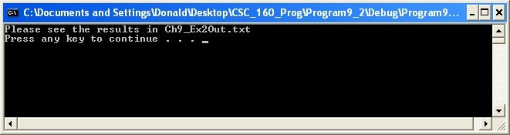

User Documentation

To run the program the user will double click Ch08_Ex14.exe located on the C drive. After the program has loaded and the design is displayed, the user will be prompted to, “Press any key to continue…” which will terminate the program. Output will be displayed on the screen.

